Name Program

OBJECTIVE: Create a new programming project that does the following:

Output the message, “My name is <insert your name here>” to the screen.

Output the message, “My birthday is <insert your birthday here>”.

Example:

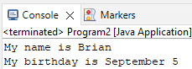

GRADING: (10 points total)

Points Objective

1 Program is able to execute without any errors.

5 The message, “My name is <insert your name here>” is outputted to the
screen.

10 Both output messages are printed successfully – similar to the example
shown above.

